## Final Assignment Report: Using HTML, CSS, and JS to Build a Website

Elizabeth Reid (41071602)

April 17th, 2023

LIB 2024 – Internet Applications

Prof.: Dr. Huthaifa Abderahman

### Table of Contents

1. Introduction page 1
2. List of Elements and Tricks Used page 2
3. Script Blocks and Comments page 4
4. SEO Standards page 8
5. Conclusion page 8
6. References page 9

### Introduction

The process of creating this website began without even considering which tags or functions I wanted to include – I began the design process by looking for inspiration for a theme that I would want to use for the overall theme of the entire site. I found a few pages that looked at though they could be done but one particular example stood out to me. I therefore decided to borrow colour, some font, and general feel for my website from the Obys Agency’s “Odin’s Crow” webpage, reference later in this report. The colour palette and the minimalist feel to the page was the same as I envisioned for this final assignment.

I then looked at what features and what content I wanted to include and would need to code into the site. I had already amalgamated my photography into a somewhat presentable portfolio, but wanted to see if this was something that I could reorganize myself. I decided that I wanted the focus of my site to be a gallery of all my images, divided by type of photo, with some mock newsletter and contact features that you might find on a photographer’s real personal webpage.

### List of Elements and Tricks Used

*The following tags are in order of use in the HTML files. Only tags not previously used are fully explained.*

**<!DOCTYPE html>**

**<html lang=“en”>**

**<link href=[…]>**

**<meta charset=“utf-8”>**

**<meta name="description" content="[…]”>**

**<meta name="keywords" content="[…]”>**

**<title>**

**<body>**

**<button class=“[…]”>**

**<!—creating link to […]-->**

**<a href=“[…]”>**

This tag creates a link to another file and attaches it to whatever element is contained within the <a> and </a> tags.

**<h1 class=“[…]”>**

**<hr class=“[…]”>**

**<p class=“[…]”>**

**<div class=“[…]”>**

**<img class=“[…]”>**

**<script src=“[…]”>**

This tag links the contents within the HTML file to the functions defined in the JS file. This tag must be included in the <body> of the HTML file.

**<form action=“”>**

This tag opens the form element that will allow users to input information and have it processed by the browser. This tag includes input tags and links to the JS function explained.

**<input id=“[…]”>**

*The following tags are in order of use in the CSS files. Only tags not previously used are fully explained.*

**body {**

**.contact {**

**.contact :hover {**

**.newsletter {**

**.newsletter :hover {**

**.head {**

**.line1 {**

**.browse {**

**.description {**

**.gallery {**

**.gallery img {**

This applies changes to all the images linked under the class called “gallery.” Only images under this class will be affected, and no images outside of this class will be affected.

**.gallery :hover {**

**.lines {**

**.lines .line[…] {**

Only the specific element under the lines class with the name found in […] will be affected by these changes.

*The following tags are in order of use in the JS files. Only tags not previously used are fully explained.*

**function myFunction() {**

This tag defines how the browser will respond when the “myFunction” function is triggered through the attached HTML file.

**alert (“[…]”);**

This element prompts the browser to create a pop-up alert that will display to the user. It reads any text included within quotations in the brackets.

**if (document.getElementById(“[…]”).value.length==0) {**

This tag, in conjunction with the later “else” tag creates a conditional function, whose product is entirely dependant on user input.

**else {**

This tag, paired with the previous “if […]” tag allows for all other entries, besides the one specified in the “if […] tag” to produce the function that follows.

### Script Blocks and Comments

*The screencaptures, from left to right, represent the HTML, CSS, and JS files.*

**Reid_Landing.html, .css, .js**

This section of the code creates the elements that will serve as the top of page, acting as a top navigation bar. HTML lines 1 through 10 open all the necessary tags for the content of the page and add keywords and a description to make the page more compliant with SEO Standards. HTML lines 14 and 18 create two buttons that will be programmed differently and will link to either a pop-up, as is created through the JS file’s lines 1-3 and is pictured below, or a separate HTML page with entirely new content, as is done through lines 17 and 19 of this HTML file. The newsletter page will be explored in the next section of this report.

The CSS file distributes the buttons across the top of the page and formats them to be uniform with each other and to match the overall theme of the website.

These two screencaptures represent the main focus of the landing page for this website. The HTML creates a small gallery of images that can then be clicked to link to another HTML page, again to be explained separately. The images are then given animations in the accompanying CSS file that emphasize the one that the user is currently hovering on by making it grow to a scale of 1.1, as defined by line 92 of the CSS file and shown in the screencapture to the right.

This CSS file also uses the border style functions in order to create a growing size of lines at the base of the page, used to contribute to the overall theme of the website, on lines 98 through 119. This effect will be used throughout the website in both the light grey colour and the darker grey colour as a way to create variety while maintaining uniformity.

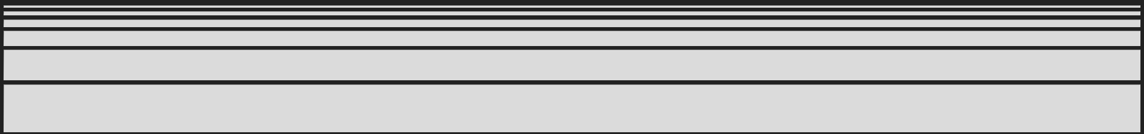

**Reid_Newsletter.html, .css, .js**

On this page, the HTML file script begins in the same way as the landing page. The difference here lies after the <body> tag is opened. The HTML file creates a form, two input elements, and a button that will allow the user to complete two text fields and submit them. The attached JS file uses a function to alert the user in three different ways, depending on the submission they had input. If either the Name or the Email field were left blank, they are alerted to the fact that these fields are required. If both are completed, they receive an alert thanking them for subscribing.

The CSS script shown above is used to, again, maintain the theme of the website. The image included in the HTML file is a screencapture of the lines mentioned previously, as I was having difficulty programming the Submit button and maintain the entirety of the top line.

**Reid_Animals.html, .css (and other image portals)**

All the pages created and linked to the images on the landing page follow the same template. The Reid_Animals.html, .css files are used to explain the coding in these pages.

The code on this webpage of my website is a fairly simple gallery designed to make the focus of the webpage the images included in the gallery. The HTML file simply added the images from the files and adjusted them to be the same height and the proportionate width to that height. The attached CSS file formatted these photos to be shown in the middle of the webpage and spanning across to both sides of the page, as shown on lines 33 through 40. The product of these snippets of code is shown below.

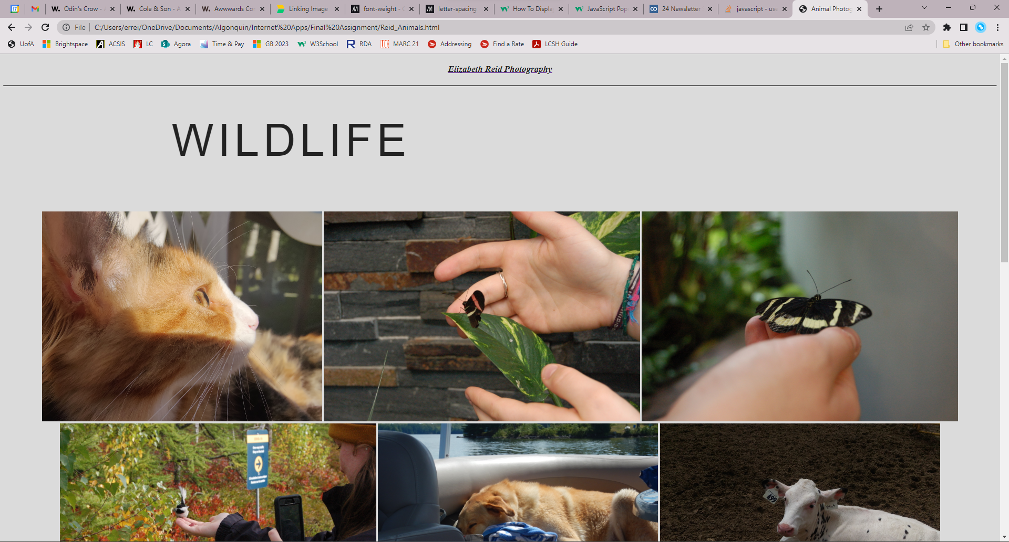

### SEO Standards

In order to comply with SEO best practices, I consulted the HubSpot “Introduction to Search Engine Optimization: Getting Started with SEO to Achieve Business Goals” short book on SEO standards. Because my website uses HTML, CSS, and JS coding, I have included a few tags, elements, and functions that would allow for a user to find my created website when searching for content that it contains.

Along the same thread as all of my previous assignments, I have included relevant keyword tags and a description in each of the HTML files, including all of the individual galleries and the newsletter and landing page. This, paired with the inclusion of individual class names and only using each heading number once, helps to make my webpages SEO compliant.

What is different with this webpage, however, is that I have also included Internal Linking between certain pages, an attribute of a webpage that HubSpot explains is “yet another way you can help out the search engines,” (HubSpot 20). I used Internal Linking as a way to link the user back to the Landing page when on any of the other pages on my website.

### Conclusion

Creating this website allowed me to engage all of the skills I learned throughout this semester and apply them in a way that created connections between the concepts learned. I was able to create a website that showcased my understanding of HTML, CSS, and JS while also showing my ability to connect them with each other and have them work in a way that followed with the SEO and UX guidelines that make the webpages produce most useful to any user who would theoretically come across my page. Throughout the semester, learning and practicing new tricks while also applying them to other types and styles of webpages allowed me to use them effectively to create this website for my final assignment.

### References

*Font-weight - CSS: Cascading style sheets: MDN*. CSS: Cascading Style Sheets | MDN. (n.d.). Retrieved April 17, 2023, from https://developer.mozilla.org/en-US/docs/Web/CSS/font-weight

*How to - display an element on hover*. W3Schools. (n.d.). Retrieved April 17, 2023, from https://www.w3schools.com/howto/howto_css_display_element_hover.asp

HubSpot. (n.d.). *Introduction to Search Engine Optimization: Getting Started with SEO to Achieve Business Goals*. *HubSpot*. Retrieved from https://www.hubspot.com/hs-fs/hub/53/file-13221845-pdf/docs/ebooks/introduction-to-seo-ebook.pdf.

*JavaScript Pop-Up Boxes*. W3Schools. (n.d.). Retrieved April 17, 2023, from https://www.w3schools.com/js/js_popup.asp

*Letter-spacing*. CSS: Cascading Style Sheets | MDN. (n.d.). Retrieved April 17, 2023, from https://developer.mozilla.org/en-US/docs/Web/CSS/letter-spacing

[User] Niemvuilaptrinh. (2022, February 18). *24 newsletter Signup Forms Code for your website*. Medium. Retrieved April 17, 2023, from https://levelup.gitconnected.com/24-newsletter-signup-forms-for-website-15736e597b7d

*Odin's crow - Awwwards SOTD*. Awwwards . (n.d.). Retrieved April 17, 2023, from https://www.awwwards.com/sites/odins-crow

PageDart, S. from. (2020, May 21). *Linking image in HTML: How to create links from images*. PageDart. Retrieved from https://pagedart.com/blog/linking-images-in-html/

[User] SanoodiaSanoodia. (n.d.). *Use different alert on user inputs*. Stack Overflow. Retrieved April 17, 2023, from https://stackoverflow.com/questions/65718436/use-different-alert-on-user-inputs

### Content Used on Webpage

All content included on this website are my own photographs.